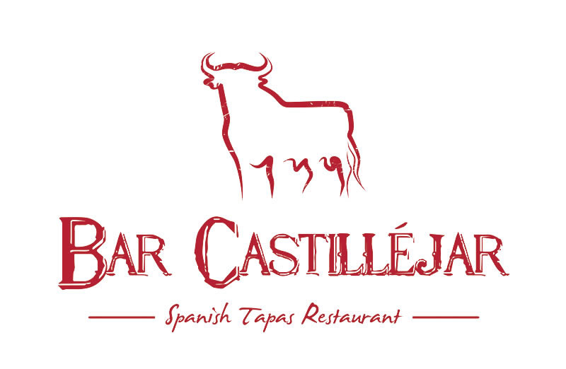

Noche Vegano Y Vegetariano 30 de Julio

V Paella de Verduras £5.00

Spanish rice with vegetables
V Olivas con Queso Mediterráneo £5.00

Spanish olives & leaf salad with Mozarella cheese
Tortilla Especial £4.50

Spanish omelet with potato, onion and spinach
V Almendras £4.00

Almonds, pan fried in olive oil, slightly salted
V Pimiento al horno £4.00
Fire roasted Spanish red peppers with garlic served on a crustini
V Pinchitos de Veduras £4.00
Skewered vegetables cooked on the BBQ
V Pimientos Padrón £3.50

Small green padron peppers from Spain, shallow fried in olive oil & salted.
V Gazpacho £3.50

Cold & refreshing Andalusian soup made with tomatoes
V Esparragos con Tomate £4.50
Pan fried asparagus with cherry tomatoes & garlic
V Calabacín, Tomate Deshidratado y Queso £4.50

Courgette with sun dried tomato, salsa, olives and cheese
V Berenjena con Miel £4.50
Aubergine roasted with honey local to Castilléjar
V Pak Choi £4.50
Pak Choi sautéed with garlic, red pepper, chilli and soy sauce
V Calabacines con Balsámico £3.50
Mediterranean courgettes, charred and served in oil, Balsamic vinegar & herbs
V Pimiento Frito £3.50

Sweet pepper deep-fried with salt
V Pan con Queso al Horno £4.50

Cheese melted on toastlets
V Champinones al ajillo £4.50

Mushroooms sautéed in garlic & pink peppercorns
V Tomate al Ajo £4.50
Four Halves of tomatoes & cherry tomatoes roasted in garlic and herbs
V Pimiento Relleno de Veduras £5.00

Baby sweet peppers stuffed with Mediterranean vegetables topped with cheese
V Alcachofa £4.50
Grilled artichoke hearts lightly seasoned
V Seta con Queso y Ajo £4.50

Grilled mushroom stuffed with soft cheese & garlic
V Patatas del Pobre £4.50

“Poor mans potatoes” Potatoes cooked in extra virgin olive oil, garlic & green pepper

